Chapter 1 – The python Data model
The data model is a description of Python as a framework. Objects have special methods that are called under the hood by this framework (double underscore methods).

Named Tuples can be used in place of full fledged objects when we need something like a struct – we can use them to build “classes of objects that are just bundles of attributes with no custom methods.”

Two advantages of leveraging the Python Data Model:
1. Users of your classes don’t have to memorize arbitrary names for standard methods (sizeof, length, etc)
2. You can benefit from the rich Python standard library, instead of reinventing the wheel (use random.choice over your object that supports __len__ and __getitem__ instead of writing an arbitrary method for it)

Also, adding the __getitem__ method automatically gives you the ability to slice your object. We also get iteration for free, and we can reverse with reversed(). Also, if we don’t have a __contains__ method, then the ‘in’ keyword default to iterating through and doing a search.

https://docs.python.org/3/library/doctest.html is a built in python module that allows you to automatically test examples from your documentation. With this you can start by writing the expected behavior in a docstring and then using doctest to check the later implementatino. For example, I could start by writing
“””
>>> v1 = Vector(2, 4)
>>> v2 = Vector(2, 1)
>>> v1 + v2
Vector(4, 5)
“””
And then move on to defining the Vector class, using this docstring as a test for the add method.

Special methods are meant to be called by the interpreter and not by you.

The bool() function will call the __bool__ method of an object, if that is not defined, it will use __len__ to see if the value is nonzero, if that Is not defined, it returns False.

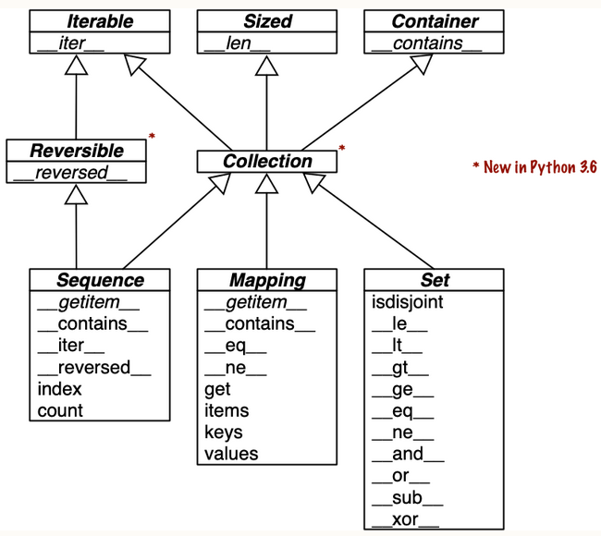
Chapter 2 – An Array of Sequences
The pyhton standard library offers two sequence types: Container sequences which can contain anything and be nested, and Flat sequences which have one simple type

An array type of floats (from array.array) is much more compact than a tuple of floats; in a tuple the floats are all python object, with metadata. In the array.array, the floats become actual machine represented floats.

If you are not doing something with the produced list, you should not use list comprehension. Don’t use it as a way to induce side effects on objects in a sequence.

Listcomps can do everything that map and filter can do, but without contrortions caused by python lambdas

Listcomps can only build lists, but genexps can generate data of any other sequence type. Gen-exp saves memory by yielding items one by one using the iterator protocol. They use the same syntax as listcomps, but use parenthesis instead of listcomps.

Things are considered hasable if they are immutable; tuples are only hashable if all of their elements are unchangable – tuples can only be used as the key to dicts if they are hashable.

Python3.10 has an awesome new feature called “destructuring” that can be used in things like the new match (case) statement.

def main():
print(f'{"":15} | {"latitude":>9} | {"longitude":>9}')
for record in metro_areas:
match record:
case [name, _, _, (lat, lon)] if lon <= 0:
print(f'{name:15} | {lat:9.4f} | {lon:9.4f}')

Slices are their own object type which can be created implicitly through the 3:1 syntax or explicitly through the slice(<start>, <end>) built in function

Slices can be used to modify and “graft” lists in place
l[2:5] = [20, 30]

f=

A Virtual subclass is a class that, although it doesn’t subclass from a common ancestor, implements all of the necessary functionality that would be required to be a subclass of that container (or use that class as an abstract base class).

The sorted function in python is implemented in C, so that makes it more efficient than any sorting function you could write in python.

Chapter 3 – Dictionaries and Sets
Dictionaries are extremely performant in python.

In python3.9+, you can use | to merge dictionaries together.
D3 = d1 | d2

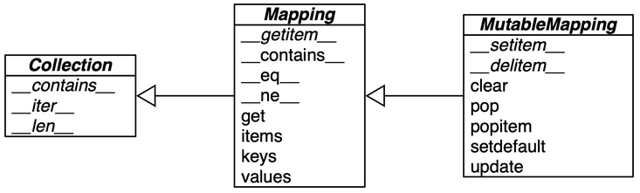
collections.abc has Mapping and MutableMapping ABCs which describe the interface for dicts

Duck Typing is a way of abstracting the type of an object, if it has the method required to make it a mapping, I’ll treat it like a mapping, otherwise if it has the method required to make it A, I’ll treat it like A (If it walks like a duck and quacks like a duck, then it must be a duck).

Handling missing keys automatically
You can either use a defaultdict or subclass a dict and add a __missing__ method. Defaultdict works behind the scenes by providing the __missing__ method.

The built in dict type has its keys ordered since Python3.6.

The collections.ChainMap type holds a list of mappings that can be searched as one.

Pickling is the process of converting a Python Object into a Byte stream. Unpickling is the inverse. It is also known as “serialization”, “marshalling” and “flattening”. The module has a “dumps” and “loads” function, just like the json module does.

Shelve is a standard library that provides storage for mappings that point to serialized pickle objects.

DBM is a simple key-value database; from original Unix; early example of NoSQL.

The items, keys and values methods of dictonaries return views.

In dicts key ordering is preserved in python3.7+.

Python object instance attributes are stored in a special dict called __dict__. In python3.3+, instances of classes share a common hash table – the common hash table is shared by the __dict__ of each new instance. Adding an instance attribute after __init__ forces python to create a new hash table just for the __dict__ of that one instance.

Set elements must be hashable. The set operations (intersection, union, difference, etc) are all very powerful and can reduce the length of a python program. The membership test for elements in a set is extremely fast because the set is implemented as a hash table. There is no notation for empty set (you can’t do {}, because thats a dict), so you have to write: set().

The order of elements in a set is not preserved.

Set comprehensions exist.

Many of the set operations (union, intersection, contains, etc) can be performed on dict views, although they can’t be updated. Be wary that you can’t perform set operations on dict items if all of the items are not hashable.

Grok - : to understand profoundly and intuitively

Chapter 4 – Unicode Text Versus Bytes
<skipping for now>

Chapter 7: Functions as First Class Objects
Having fucntions as first class objects is a prerequesite to functional languages, but having this feature does not make a language functinoal – Java, Go and JavaScript all have this feature.

Higher Order Functions are functions that take a function as an argument or return functions as a result

List compreshensions accomlish the same goals as filter, map, reduce, but are recommended since they are “more elegant and built in python features”

There are some built in reducing functions: sum, reduce, all, any

The operator module provides functions for all of the built in arithmetic operations. It also provides the itemgetter function, which can grab certain arguments from a collection. Basically this class contains operators that help you in list comprehensions, you can use these classes instead of creating a lambda that does the same thing.

The functools module provides several higher-order functions. Partial is a function that is commonly used – you can give it a partial set of arguments to pass to a function, and returns a new function. partial(lambda a, b: a*b, 3)(7)
functools also provides some other higher order functinos meant to be used as decorators.

Chapter 8 – Type Hints in Functions
The rational is to help developer tools find bugs in Python codebases via static analysis.
This is part of a gradual type system,

Liskov substitution principle (LSP): Subtype Requirement: Let be a property provable about objects of type T. Then should be true for objects of type S where S is a subtype of T.

<skipping ahead again> - Left off at Generic Collections

Chapter 9 – Decorators and Closures
nonlocal is a keyword introduced in python3 that is used in the context of decorators.

Decorators are based on closures, which allows us to capture variables outside of function bodies. A decorator is a callable that takes another function as its argument. It does some processing with the decorated function, and returns it or replaces it with another callable.

@decorate
def target():
print(“Running target()”)

is the same as running

def target():
print(“Running target()”)
target = decorate(target)

Function decorators are executed as soon as a module is imported.

Code that uses inner functions almost always depends on closures to operate correctly.

Variable Scopes
If a variable is used at all in the scope of a function, that function uses the local version.

When python compiles the body of the function, it decides that b is a local variable.

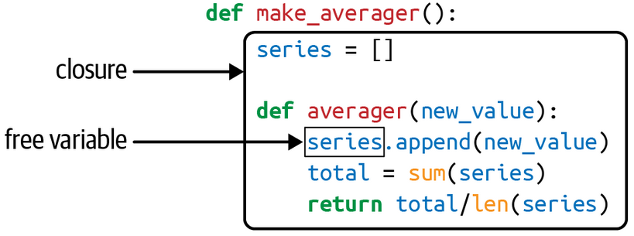
A closure is a function with an extended scope, that uses variables that are not global and not local to the function, such variables come from a function that encompasses this one (an inner function that uses variables from the outer function).

The variable used from the outer function in a closure is called a free variable, a technical term.

Decorators in the Standard Library
There are three built in functions designed to decorate functions: property, classmethod, staticmethod. The functools module also has some cacheing decorators.

You can apply multiple decorators to a function, this is called stacked decorators.

@alpha
@beta
def my_fn():
…

is the same as

my_fn = aplha(beta(my_fn))

The built in cache decorator is unbounded… so be wary of using this. The lru_cache decorator is bounded and makes more sense for longer running things.

Since python3.2 you can call decorators with parameters

@lru_cache(maxsize=2**20, typed=True)
def costly_function(a, b):
…

Single Dispatch Generic Functions
Decorating a function with the @singledispatch decorator will make that function an entry point for a generic function – this is a way to accomplish something like overloaded parameters.
The singledispatch logic will choose the function with the best matchiung type – for example, bools are technicaly integral types, but if you have a dispatch handler that takes in integral, and another that takes in bool, it will match the bool

Parameterized Decorators
To make a decorator that takes arguments, you have to create a decorator factory that takes in the arguments and returns a decorator.

Locals() gives you access to all of the local variables in a scope

Decorators can be implemented with classes implementing __call__, and the author states that this is a better approach for non-trivial decorators.

Chapter 10: Design Patterns with First Class Functions
Many of the design patterns from the GoF book are not relevant in languages such as python, this is because there are language features that are provided that invalidate some of the patterns (or implement a version of the pattern already).

“The goal of this chapter is to show how—in some cases—functions can do the same work as classes, with code that is more readable and concise.”

Strategy Design Pattern
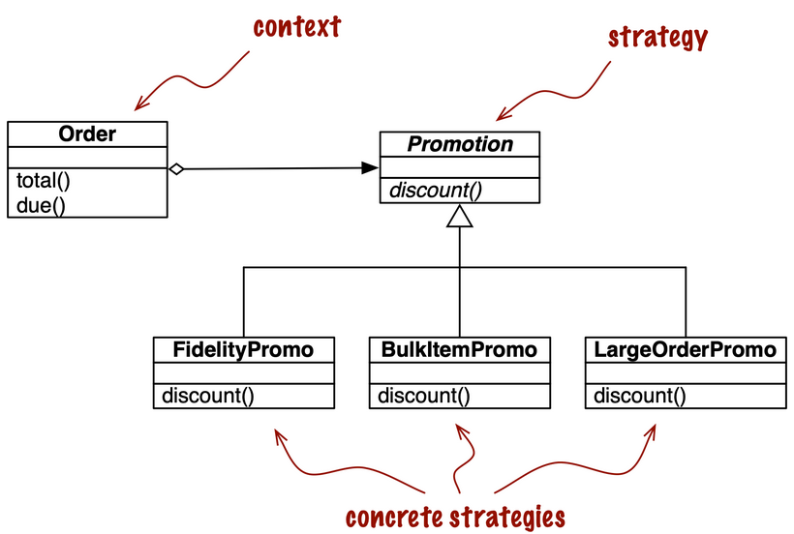
From GOF: “Define a family of algorithms, encapsulate each one, and make them interchangeable. Strategy lets the algorithm vary independently from clients that use it.”

One clear example is applying different types of discounts (bulk discount, large order discount, coupon discount, etc).

There are many different methods of introspection in python, ways that you could grab all functions that match a certain type

You could use globals() and then search the dict for functions that match a certain name

[func for name, func in globals().items if name.endswith(‘_myfunc’)]

Or you could put all of the functinos in a module, and import the module, and then search the module for functinos using the inspect module.

[func for _, func in inspect.getmembers(mymodule, inspect.isfunction)]

We’re able to do this sort of stuff because modules are also first class objects.

You could also use a decorator to register functions that you want to catch.

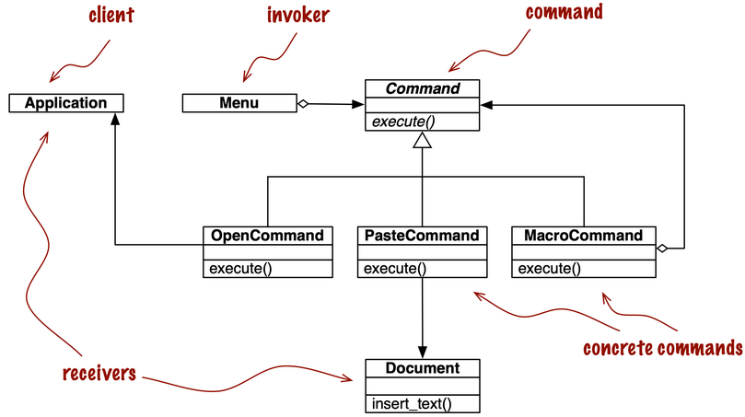
The Command Pattern
The goal of Command is to decouple an object that invokes an operation (the invoker) from the provider object that implements it (the receiver).

I don’t completely understand, but here again, he replaces the single method interface objects with callables.

Chapter 11 – A Pythonic Object
The @classmethod decorator defines a method that operates on the class, and not on instances. The most common use is for alternative constructors.

The @staticmethod decorator changes a method so that it receives no special first argument (self).

In the strong method format, the formatting of each type is handled by calling the objects __format__ method.

>>> f"{string:%^50}"
'%%%%%%%%%%%%%%%%%%%Hello Friend%%%%%%%%%%%%%%%%%%%'
>>> f"{string=:%^50}"
'string=%%%%%%%%%%%%%%%%%%%Hello Friend%%%%%%%%%%%%%%%%%%%'

>>> f"{500:0>32b}"
'00000000000000000000000111110100'

TO make your custom object type hashable, you need to implement the __hash__ method – implementing __eq__ is also required. The object must also be immutable.

You can make properties read only by using the @property decorator to create a getter, and using two underscores for the variable names to make them private.

Objects that compare equal should have the same hash.

Private and “protected” attributes in python
There is no “private” keyword like in Java, but you can use Name Mangling to hide variables to some extent. Prefix the variable with a __ and then internally it will be stored as _<class name>__<variable>
This is not universally accepted as best practice by python programmers. Many programmers emphasize privatization by practice, naming the variables with a certain paradigm and knowing how to use it. For example, using a single underscore, and knowing as the programmer, that all properties with a single underscore at the beginning are off limits.

The __slots__ attribute
__slots__ is a special attribute that causes classes to not use the built in __dict__ attribute; instead instance attributes are stored in a hidden array. The variables of the class then become set however.

__slots__ is only partially inherited by subclasses though. The array exists, but the subclass also has a __dict__ attribute, unless __slots__ is defined explicitly. The __slots__ of the subclass are in addition to that of the base class.

This special attribute can save a significant amount of space if used properly, but it can also cause confusion or raise the complexity of the program.

Chapter 12 – Special Methods for Sequences
Protocols and Duck Typing
You don’t have to inherit from the sequence type in order to implement a sequence, you just have to implement the protocol of the sequence type. The protocol is an informal interface, defined in documentation and not in code. In python, we say that a object is of a certain type if it behaves like one: If it behaves like a duck, it is a duck.

__getattr__ is called when attribute lookup fails

Chapter 13 – Interfaces, Protocols and ABCs
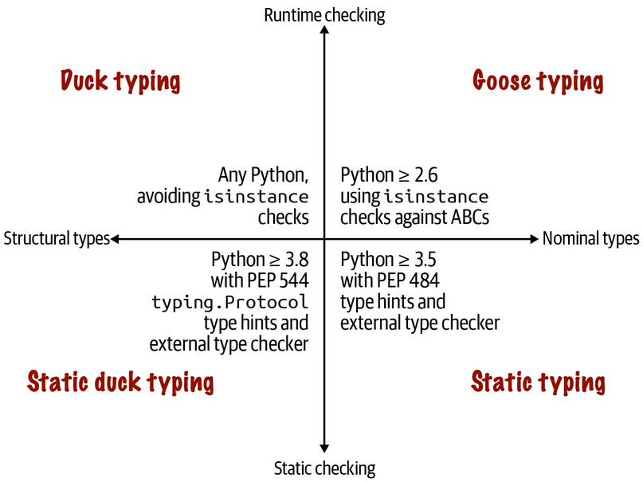
There are four ways to define and use interfaces in Python. Duck Typing, Goose Typing, Static Typing, and Static Duck Typing.

With objects using a “dynamic protocol” (duck typing), the object may only need to implement part of the protocol to be useful. Whereas for a “static protocol” (static duck typing), the entire thing must be implemented to be verified by the static type checkers. Through neither of these protocols do you have to use inheritance to achieve the protocol – as long as the correct methods are implemented, the protocol is satisfied.

By deftauly, if __getitem__ is implemented for an object, python will attempt to iterate over the object using sequential integer increments, trying until an invalid index error is raised by the object. SO this means that even though the ‘sequence’ protocol is minimally supported by __getitem__, if your container is something other than just a list (such as a dict, or multiple lists), you will need to implement the __iter__ method in order to properly iterate through it (either that or do some real funny business in the __getitem__ method).

The python works really really hard to find anything that vaguely resembles a sequence. The logic to try iterating through is all implemented in C as part of the interpreter itself.

Monkey patching is dynamically changing a module, class or function at runtime, to add features or fix bugs.

The fail fast philosophy aims to catch runtime bugs as soon as possible and make them easier to solve. Do type checking at the beginning of functions; this type checking might be checking that an object implements a protocol rather than being a particular type. One way to check for particualr attribute is to try and call the method and catch the error: “it’s easier to ask forgiveness than permission”

try:
field_names = field_names.replace(‘,’, ‘ ‘).split()
except AttributeError:
# Looks like field_names isn’t a string
pass

“An abstract class represents an interface.” - Bjarne Stroustrup

ABCs allow us to define interfaces on python objects, insuring that certain objects contain certain methods. Virtual Subclasses are classes that don’t inherit from a class, but are recognized by isinstance() and issubclass() because they implement the correct methods.

An example of where ducktyping falls short

class Artist:
def draw(self): …

class Gunslinger:
def draw(self): …

class Lottery:
def draw(self): …

Goosetyping involves using ABCs. With goosetyping, you subclass from ABCs and perform runtime checks against ABCs instead of concrete classes – isinstance(obj, abc) and issubclass(obj, abc). More than just implementing required methods, subclassing an ABC is a depiction of intent on the part of the developer.

You can register a class as a virtual subclass using

from collections.abc import Sequence
Sequence.register(FrenchDeck)

doing the isinstance / issubclass checking against ABCs makes things more flexible, since virtual subclasses can be created – it allows for greater polymorphism.

Python does not check for implementation of abstract methods at import time, it only checks them at runtime when the object that inherits from the ABC is instantiated.

Mixin Methods are concrete methods that you get from inheriting from an ABC. According to wikipedia, a mixin is a class that gives another class certain methods without having to be a parent class. From a stack overflow answer, two reasons you would use a mixin is
- You want to provide a lot of optional features to a class
- You want to use one particular feature in a lot of different classes

Mixin classes are no meant to be standalone, they complement existing objects.

Nominal typing is the traditional sort of typign derived from inheritance; structural typing is based off of fucntionality / behavior – Duck typing is a particular approach to structural typing. The isinstance and issubclass functions can support structural type checking for classes that implement the __subclasshook__ method, which returns true if a provided class is a virual sub class of the class in which it is implemented; this method often checks that the given object contains the necessary methods to implement the required behavior of the object.

Structural Type checking can be performed now via the Protocol class from the typing module. Essentially you can define that a type needs to have a particular method that takes in and returns a particular argument type. You can say that an object needs to quack in order to be used in this function.

When we implement static duck typing, we do not have to subclass; as long as a class implements the required methods of a protocol, it is essentially an instance of that protocol – we can create a protocol class, and then use isinstance to check if our class that implements the required protocol is an instance of it (it is). Though in order to do this isinstance check, you have to add a @runtime_checkable decorator to your created protocol

from typing import Protocol, runtime_checkable, Any

@runtime_checkable
class RandomPicker(Protocol):
def pick(self) -> Any: …

Chapter 14 – Inheritance
The argument against inheritance in 2021 is that it is overused. Since superclasses and subclasses are tightly coupled, this means that changes to one part of the program can have unexpected and far reaching effects in other parts, making systems brittle and hard to understand.

super() returns a “dynamic proxy object” that allows it to find the desired method of a superclass

You should never subclass a built in type because python does not follow the Late Binding principle. If you subclass list, and overwrite the __setitem__ method, calling append() on your subclass won’t do what you want it to, because it will use list’s __setitem__ instead of your subclasses’s __setitem__

Python inheritance is based upon cooperative methods, meaning that each method is expected to call super so that it is passed to the next node. The inheritance call list for super() is not intuitive, and calling super() in your method does not mean it will necessarilly call it’s super class’s version of the method – the method for all of the classes involved must be cooperative: i.e. they must all call super.

Mixin Classes are designed to be subclassed together with at least one other class in a multiple inheritance arrangement. It kind of adds flavor to an object, it doesn’t provide base functionality, only extends functionality.

You should avoid inheriting from concrete classes – those classes may have attributes that store internal state; methods that you overwrite may depend on those internal state and you might cause corruption.

